L19:

<b> tag: bold

<strong> tag: bold

<i>: emphasis (斜体)

<em> tag: emphasis

L21

<ol> <li> </li><li> </li><li> </li> </ol>

<ul> <li>

L23

<div> 同一行的东西加上div会被换行

<span> 不会换行

L24: attributes

<img src=”corgi.png”>

<p class=”selected”>woof woof</p>

<a href=”[www.google.com](http://www.google.com)”> Click me</a>

<link rel=”stylesheet” type=”text/css” href=”style.css”>

L28: table

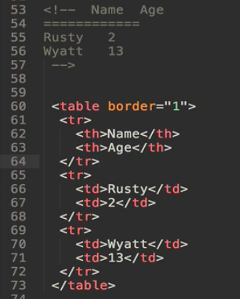

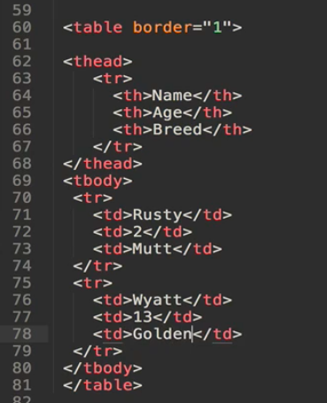

L31: form tag and input tag

<form action=”/my-form-submitting-page” method=”POST” > </form>

<input type=”text”>

<input type=”date”>

<input type=”color”>

<input type=”file”>

<input type=”checkbox”>

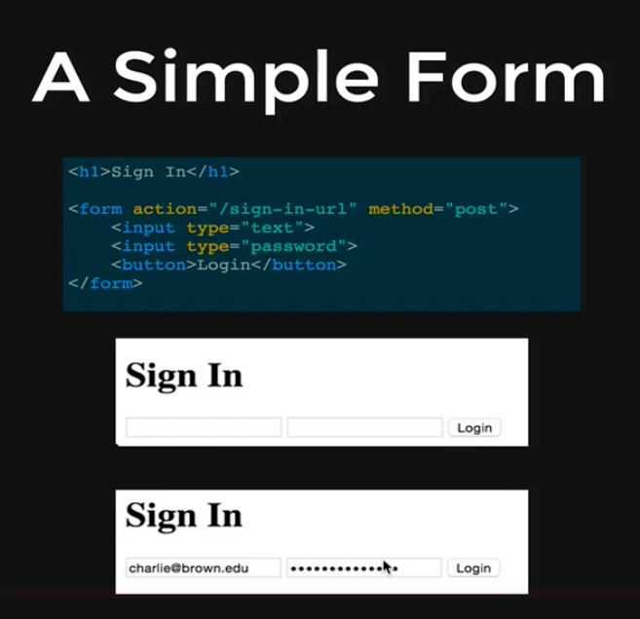

L33

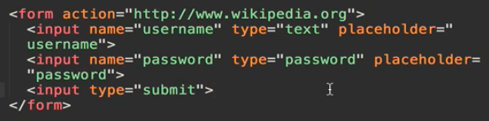

Need the name for input so that you can see the query in the browser

L36：dropdown choice

<select name=”color”>

<option>Red</option>

<option>Green</option>

<option>Blue</option>

</select>